🧠 Session 1: Introduction to Version Control & Git
1️⃣ What is Version Control?
Explain with real-life example:
- Google Docs version history
- Multiple developers working on same code
Problems without Git
- Code overwrite
- No rollback
- No collaboration
2️⃣ Types of Version Control
- Local
- Centralized (SVN)
- Distributed (Git) ✅
3️⃣ What is Git?
- Distributed Version Control System
- Created by Linus Torvalds
- Works locally (no internet needed)
4️⃣ Git vs GitHub (Very Important)
Git | GitHub
Tool | Platform
Runs locally | Cloud-based
Version control | Repository hosting
CLI-based | UI + Collaboration

💻 DEMO 1: Git Installation & Setup
git --version
git config --global user.name "Rishav"
git config --global user.email "rishav@gmail.com"
git config --list
Explain why config is needed

🧠 Session 2: Git Basics (Core Concepts)
5️⃣ Git Architecture (MUST DRAW DIAGRAM)
- Working Directory
- Staging Area
- Local Repository
📌 Explain with flow:
Working Directory → Staging → Local Repo
Working Directory → Staging Area → Local Repository
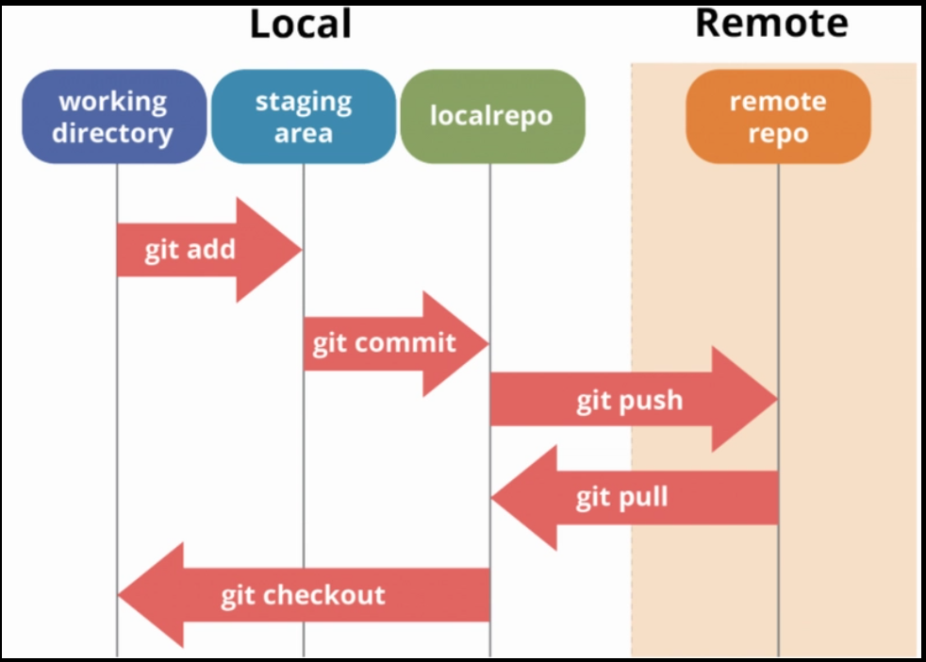

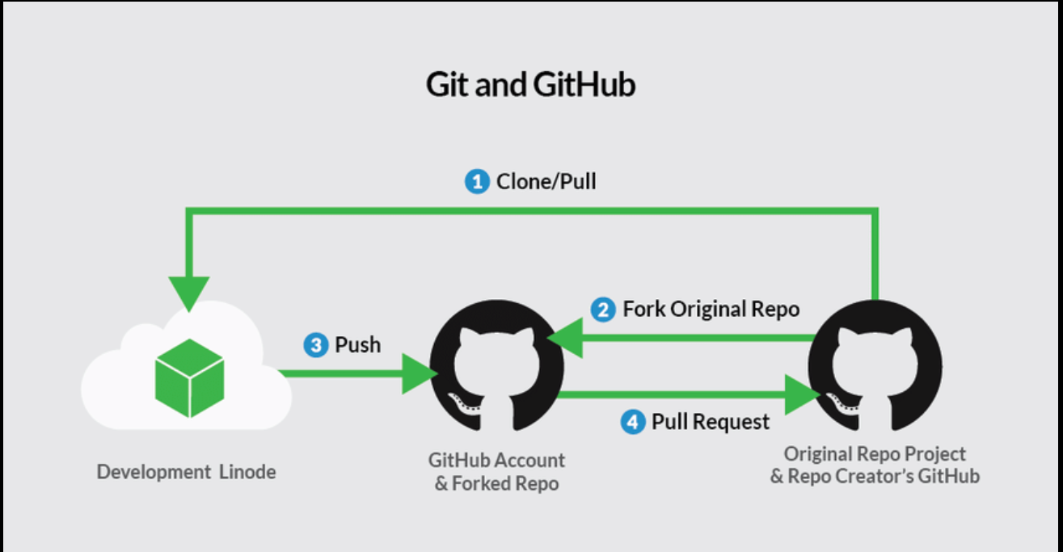
6️⃣ Create First Repository (Demo)
mkdir git-demo
cd git-demo
git init
Explain .git folder

7️⃣ Basic Git Commands (Hands-on)
touch file1.txt
git status
git add file1.txt
git commit -m "First commit"
Explain:
- git status
- git add
- git commit

🧠 Session 3: Tracking & History
8️⃣ Modify File & Track Changes
echo "Hello Git" >> file1.txt
git diff
git add file1.txt
git commit -m "Updated file1"
9️⃣ Git Log & History
git log
git log --oneline
git show <commit-id>

🧠 Session 4: Branching (VERY IMPORTANT)
🔀 What is a Branch?
- Parallel development
- Feature isolation
DEMO 2: Branching
git branch
git branch feature1
git checkout feature1
# OR
git checkout -b feature1
Make changes → commit
Merge Branch
git checkout main
git merge feature1
Explain Fast-forward vs Merge commit

🧠 Session 5: GitHub Introduction
🔹 What is GitHub?
- Code hosting
- Collaboration
- Issues, PRs, Actions
🔹 Create GitHub Account
Explain:
- Repository
- Public vs Private
- README.md

🌍 DEMO 3: Push Local Repo to GitHub
git remote add origin https://github.com/user/repo.git
git branch -M main
git push -u origin main
Explain:
- origin
- main
- -u

🧠 Session 6: Clone, Pull & Collaboration
Clone Repository
git clone https://github.com/user/repo.git
Pull Latest Changes
git pull origin main
Fetch vs Pull (Interview Question)

🧠 Session 7: Undo & Recovery (🔥 Interview Favorite)
Undo Commands
git checkout -- file.txt
git reset HEAD file.txt
git reset --soft HEAD~1
git reset --hard HEAD~1
git revert <commit-id>
Explain difference:
- reset vs revert

🧠 Session 8: Merge Conflicts (Live Demo)
Steps:
- Same file modified in two branches
- Try merge
- Conflict occurs
- Resolve manually
- Commit again

🧠 Session 9: GitHub Collaboration Workflow
Fork → Clone → Change → Push → Pull Request
Explain PR lifecycle:
- Review
- Approve
- Merge

🧠 Session 10: Best Practices + Interview Qs
Best Practices
- Meaningful commit messages
- Small commits
- Pull before push
- Use .gitignore
Common Interview Questions
- Git vs GitHub
- Merge vs Rebase
- Reset vs Revert
- Cherry-pick
- Detached HEAD

No worries at all 🙂 — this topic confuses almost everyone the first time.
Let’s reset and explain it very slowly, like you’re explaining to a beginner in class.

🧠 First, the CORE IDEA (one sentence)
A merge conflict happens when Git does not know which change to keep.
That’s it. Nothing scary.

📌 Think Like This (Real-Life Example)
Imagine two people editing the same sentence in a Word file.
Original sentence:
I love tea
Person A changes it to:
I love coffee
Person B changes it to:
I love chai
Now you ask Git:
👉 “Please merge both changes”
Git says:
❌ “Boss, both changed the SAME line. Which one should I keep?”
👉 That confusion = merge conflict

📌 Simple Git Diagram (Visual in Mind)
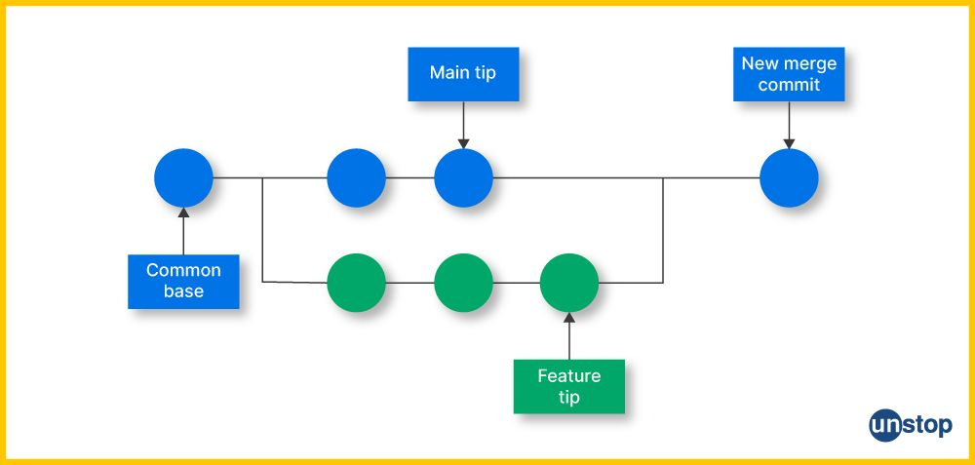

Same file, same line
main ------------------>
I love coffee

feature ------------------>
I love chai

MERGE ❌ → Git is confused

🧠 Now Git Example (Step by Step, NO JUMPING)
Step 1️⃣ One file exists
app.txt
Hello World
Committed in main branch.

Step 2️⃣ Create feature branch
git checkout -b feature
Change file:
Hello from FEATURE
Commit it.

Step 3️⃣ Go back to main branch
git checkout main
Change SAME file, SAME line:
Hello from MAIN
Commit it.

Step 4️⃣ Now merge feature into main
git merge feature
🚨 Conflict happens HERE
Why?
- Same file ✔
- Same line ✔
- Two different values ❌

🧾 What Git Shows (MOST IMPORTANT PART)
Open app.txt:
<<<<<<< HEAD
Hello from MAIN
=======
Hello from FEATURE
>>>>>>> feature
Read this like English:
- HEAD → your current branch (main)
- ======= → separator
- feature → incoming branch
👉 Git is saying:
“You decide what should remain.”

✅ How YOU resolve it (You are the boss now)
Option 1️⃣ Keep MAIN
Hello from MAIN
Option 2️⃣ Keep FEATURE
Hello from FEATURE
Option 3️⃣ Keep BOTH
Hello from MAIN
Hello from FEATURE
⚠️ You must remove:
<<<<<<<
=======
>>>>>>>

✔️ Final Step (Tell Git you fixed it)
git add app.txt
git commit -m "Resolved merge conflict"
Now conflict is gone 🎉

🧠 One-Line Student Explanation (Memorize This)
Merge conflict happens when two branches modify the same line of the same file and Git cannot decide automatically.

❌ When Conflict DOES NOT Happen
Scenario | Conflict?
Different files | ❌ No
Same file, different lines | ❌ No
Same file, same line | ✅ YES

